SHORTHORN BREEDPLAN ENROLMENT FORM 2010
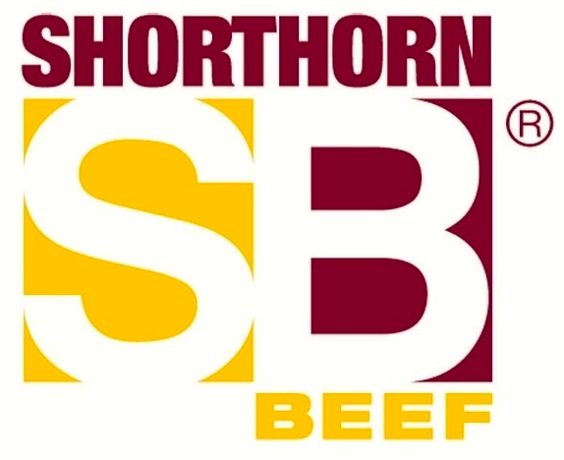
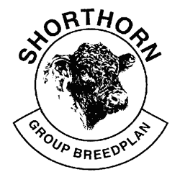

I wish to enrol my herd in Shorthorn Breedplan, the integrated pedigree and performance recording scheme for the Shorthorn Society of Australia.
Please note that all Breedplan fees are incorporated in Society annual inventory fees.
The Applicant must be a Full Financial Member of the Shorthorn Society of Australia Ltd.
Shorthorn Society Membership No:________________________
Herd Prefix:___________________________________________
Name:___________________________________________
Postal Address:________________________________________
Postcode:________________________________________

Property Address:______________________________________
Postcode:____________________________________________
Contact Person:________________________________________
Phone:_______________________________________________

Signed:____________________________________ Date:________________

Please return this application to The Shorthorn Society of Australia Ltd, ABRI, UNE, Armidale NSW 2351 FOR FURTHER DETAILS PLEASE CONTACT
ADMINISTRATION
Kayla Preston, Registrar, Shorthorn Society of Australia Ltd, ABRI, UNE, Armidale NSW 2351 Phone: 02 6772 2400 Fax: 02 6772 2244 Email: kpreston@shorthornbeef.com.au
PROCESSING
Shorthorn Breedplan Agricultural Business Research Institute Armidale NSW 2351 Phone: 02 6773 3032 Fax: 02 6772 5376 E-mail: shorthorn@breedplan.une.edu.au

SHORTHORN BREEDPLAN- HERD DETAILS
START OF CALVING YEAR
I consider my calving year to be the 12 months starting:............................... (Nominate month)
CALVING SEASONS Start End
Allocate your Summer ……………….. ……………….

Calving(s) Autumn …………….. …………….

to the Winter …………….. …………….
appropriate season(s) Spring …………….. …………….

GROUP BREEDPLAN HERD REPORTS I would prefer the following report.
o January o April o Both (Additional Fee)
One herd report is included in the BREEDPLAN standard fees. Please note that additional reports will be $55.00 (GST inclusive).
METHOD BY WHICH YOU WILL BE SUBMITTING PERFORMANCE INFORMATION TO BREEDPLAN
o Paper
o BREEDPLAN compatible herd recording computer program (eg. Herdmaster, Stockbook, Cattlelink)
o Internet Solutions Web Performance Submission Facility o BREEDPLAN compatible Microsoft Excel template
ASSOCIATED HERDS Yes/No
Is your Shorthorn Performance Herd run in association with another Shorthorn member’s herd?
If yes, we will contact you to clarify this association.

EXTRA PERFORMANCE / BACK RECORDS
Yes, I will require extra performance recording forms for the following calving years and seasons:

Years Season Years Season

……………. ……………. …………….. ……………….

……………. ……………. …………….. ……………….

